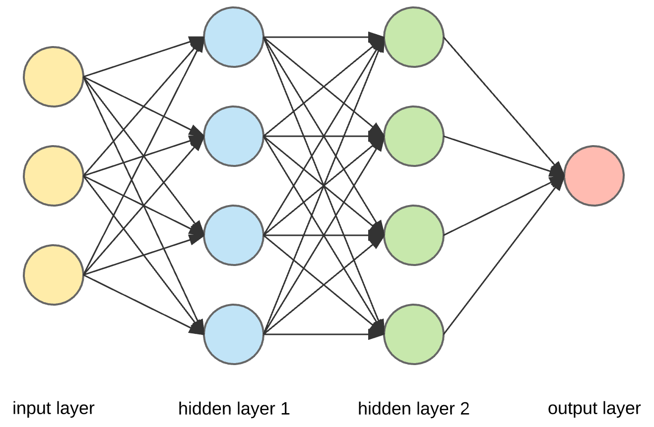

**Emotion**

**Chat Bot**

**Tweets**

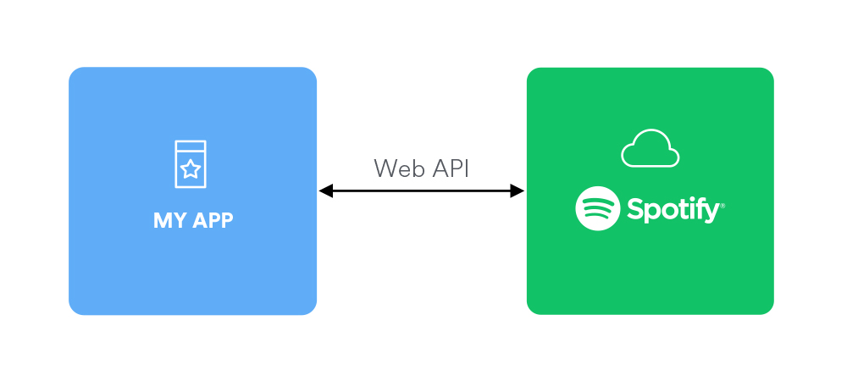

**Emotion Detection Model**

**Emotion**

**Audio**

**features**



**Recommendations**